# **SQL Queries for car sales data analysis**

Question 1 : Average Selling price by Year

Sol : SELECT year, AVG(sellingprice) AS avg_selling_price FROM car_sql_cleaned GROUP BY year ORDER BY year;

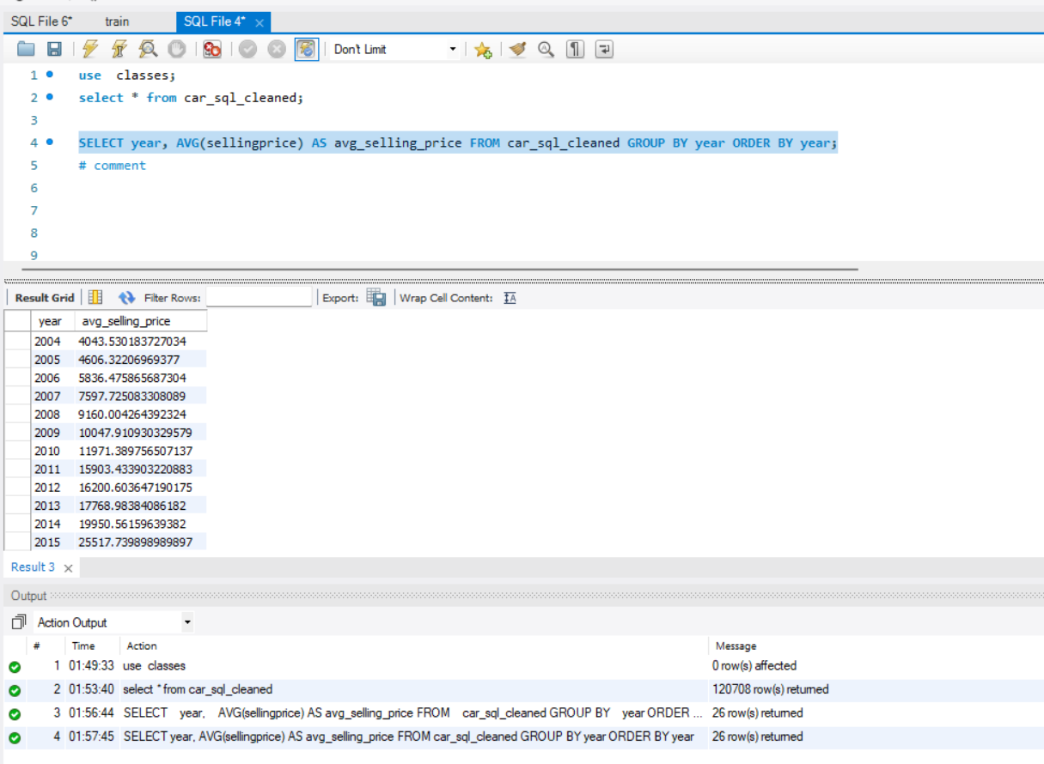

Question 2: Top 5 selling models by count

Solution : SELECT model, COUNT(*) AS count FROM car_sql_cleaned GROUP BY model ORDER BY count DESC LIMIT 5;

Question 3: Average Odometer reading by transmission type

Solution : SELECT transmission, AVG(odometer) AS avg_odometer FROM car_sql_cleaned GROUP BY transmission;

Question 4 : Sales of Each state

Solution : SELECT state, COUNT(*) AS count FROM car_sql_cleaned GROUP BY state ORDER BY count DESC;

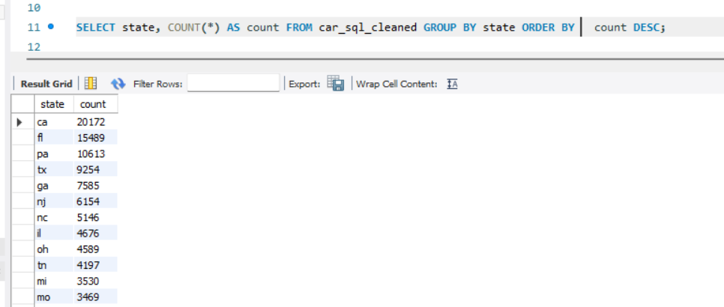

Question 5 : Number of sales of Each Month

Solution: SELECT sale_month, COUNT(*) AS count FROM car_sql_cleaned GROUP BY sale_month ORDER BY count DESC;

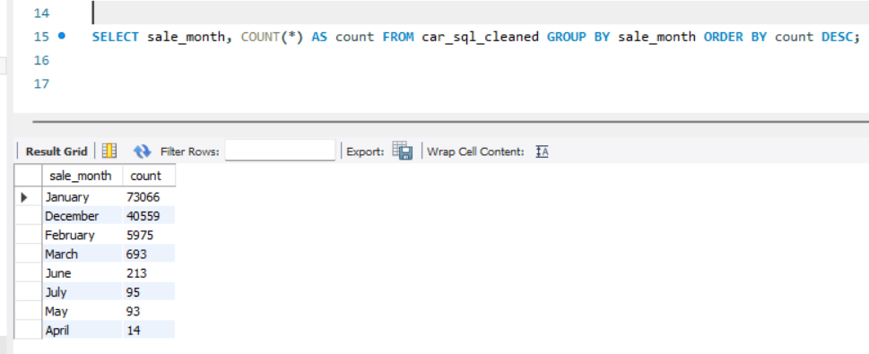

Question 6 : Average selling price by manufacturer

Solution : SELECT make, AVG(sellingprice) AS avg_selling_price FROM car_sql_cleaned GROUP BY make ORDER BY avg_selling_price DESC;

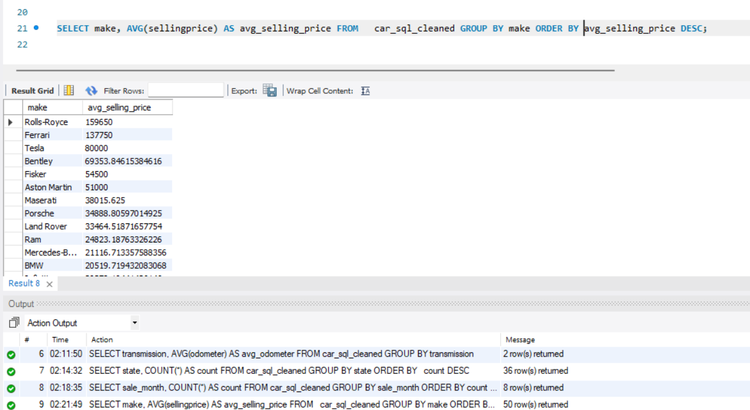

Question 7 : Top 5 trim level by count

Solution :

SELECT trim, COUNT(*) AS count FROM car_sql_cleaned GROUP BY trim ORDER BY count DESC LIMIT 5;

Question 8 : Average Odometer reading of each body type

Solution :

SELECT body, AVG(odometer) AS avg_odometer FROM car_sql_cleaned GROUP BY body;

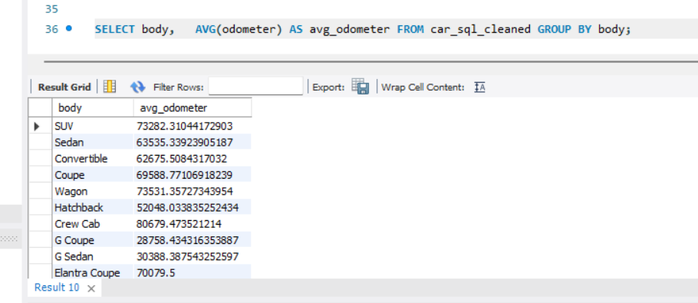

Question 9 : Sales of each interior car

Solution : SELECT interior, COUNT(*) AS count FROM car_sql_cleaned GROUP BY interior ORDER BY count DESC;

Question 10 : Average sales done by each seller

Solution :

SELECT seller, AVG(sellingprice) AS avg_selling_price FROM car_sql_cleaned GROUP BY seller ORDER BY avg_selling_price DESC;

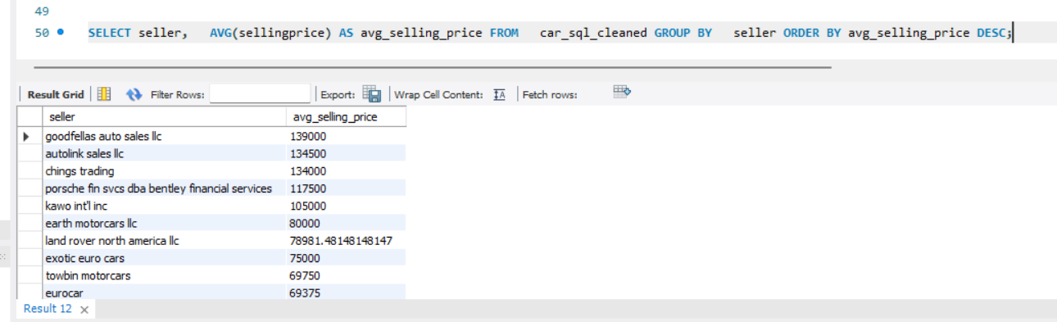

By :

Rahul Kumar (9871454372)